Interbranch Transaction Manager

This new module automates all interbranch-related transactions among GIS users. This is applicable to GIS users that are already on SQL2008 and SQL2000. The current users that will take advantage of this feature are BRAC of B.C. Ltd., Devon Transport Ltd and BRAC of Victoria Ltd.

GIS identifies all interbranch contracts such as:
- Contracts involving at least one vehicle for which the
  - Pick up location is foreign OR
  - Drop off location is foreign
- Contracts involving a foreign vehicle

There are 3 types of interbranch transactions:
- One Way – Owning company of the vehicle sends the vehicle to a location belonging to another owning company
- Local Rental – Renting company rents a vehicle belonging to another owning company locally
- Rent back/Send back – Renting Company rents a foreign vehicle back to a location that belongs to the vehicle owning company or to a location closer to the vehicle owning company

Here are a few of the many benefits the Interbranch Transaction Manager will bring:
- No more missing vehicles, kilometers and revenue
- Saves time and money
- Eliminates data entry and ensures accuracy
- Better coordination among companies
- Contract Check Out

When an interbranch contract is opened at the renting city, Interbranch Manager will first identify the owning company of both the vehicle which was checked out and the drop off location. The program will then replicate all data on the opened contract to the GIS systems of the owning company of the vehicle as well as the receiving city respectively. All auto-generated contracts will reference the original rental agreement number from the renting city.

When a contract is checked out, the renting city will initiate the replication.

All scenarios below are from Vancouver’s perspective and are labelled “Local”.

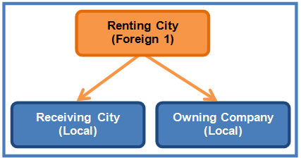
Scenario 1: Rent Back/ Send Back

Nanaimo Downtown rents a Budget Vancouver vehicle to Vancouver Downtown on contract# 3033111. The original contract is opened on Devon’s GIS. Interbranch manager will now update both the receiving city and owning company.

Since the receiving city is a Budget Vancouver location and the owning company of the vehicle on contract is also Budget Vancouver, Interbranch Manager will automatically create a contract in Budget Vancouver’s GIS using Devon’s contract# 3033111 as the foreign contract number.

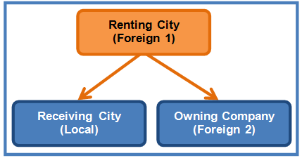
Scenario 2: Rent Back/ Send Back

Nanaimo Downtown rents a Budget Victoria vehicle one way to Vancouver Downtown on contract# 3033222. The original contract is opened on Devon’s GIS. Interbranch manager will now update both the receiving city and owning company.

Since the receiving city is a Budget Vancouver location, Interbranch Manager will automatically create a contract in Budget Vancouver’s GIS using Devon’s contract# 3033222 as the foreign contract number.

Since the vehicle on contract belongs to Budget Victoria, Interbranch Manager will also create a contract in Budget Victoria’s GIS using Devon’s contract# 3033222 as the foreign contract number.

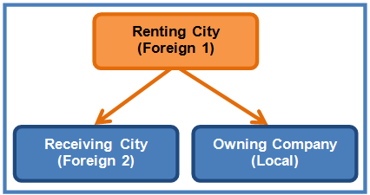
Scenario 3: Rent Back/ Send Back

Nanaimo Downtown rents a Budget Vancouver vehicle one way to Victoria Midtown on contract# 3033333.

Similar to Scenario 2, Interbranch Manager will automatically create a contract in Budget Victoria’s GIS and in Budget Vancouver’s GIS respectively using Devon’s contract# 3033333 as the foreign contract number.

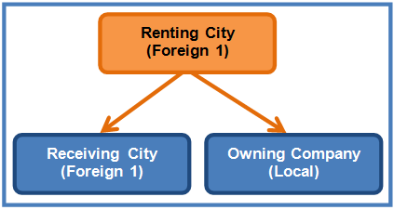
Scenario 4: Local Rental

Nanaimo Downtown rents a Budget Vancouver vehicle around town on contract# 3033444.

After the contract is opened on Devon’s GIS, Interbranch Manager will automatically create a contract in the vehicle owning company, in this case Budget Vancouver’s GIS using Devon’s contract# 3033444 as the foreign contract number.

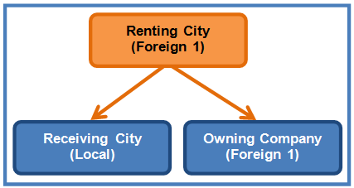
Scenario 5: One Way Rental

Nanaimo Downtown rents a Devon vehicle to Vancouver Downtown on contract# 3033555.

Since the receiving city is a Budget Vancouver location, Interbranch Manager will automatically create a contract in Budget Vancouver’s GIS using Devon’s contract# 3033555 as the foreign contract number.
- Check In

When an interbranch contract is closed at the receiving city, Interbranch Manager will identify the owning company of both the vehicle which was checked out and the pickup location. The program will then replicate all data on the closed contract to the GIS systems of the owning company of the vehicle as well as the renting city respectively. A new Interbranch Transaction Manager module under the Contract menu will be added to display all contracts pending checkin that involving a foreign drop off location. Users at the renting city would have to select the contract they want to close from this new module and proceed to collect payment. Users at the owning company would have to select the contract they want to close from this new module and record any payment information.

All scenarios below are from Vancouver’s perspective and are labelled “Local”.

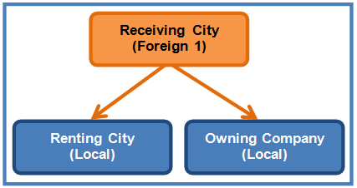
Scenario 1: Closing a One Way Rental

Vancouver Downtown rents a Budget Vancouver vehicle to Nanaimo Downtown. Interbranch Manager will create a contract in Devon’s GIS using Vancouver’s contract number as the foreign contract number.

When the customer drops off the vehicle at Nanaimo Downtown, Devon’s CSR can retrieve the contract by the foreign contract number (or search by customer name, unit number, license plate) and check in the contract.

Interbranch Manager will replicate the closing information and any extra charge items on the contract to Budget Vancouver. This contract will appear on Budget Vancouver’s Interbranch Transaction Module and Budget Vancouver’s DOP can pull out the original contract, review to ensure the charges are correct, collect payment and check in the vehicle.

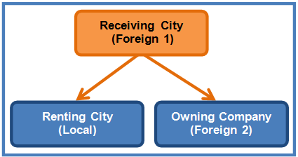
Scenario 2: Closing a Rent Back/ Send Back

Vancouver Downtown rents a Budget Victoria vehicle to Nanaimo Downtown. Interbranch Manager will create a contract in both Devon and Budget Victoria’s GIS using Vancouver’s contract number as the foreign contract number.

When the customer drops off the vehicle at Nanaimo Downtown, Devon’s CSR can retrieve the contract by the foreign contract number and check in the contract.

Interbranch Manager will replicate the closing information and any extra charge items on the contract to Budget Vancouver and Budget Victoria. This contract will appear on Budget Vancouver’s Interbranch Transaction Module and Budget Vancouver’s DOP can pull out the original contract, review to ensure the charges are correct, collect payment and check in the vehicle. This contract will also appear on Budget Victoria’s Interbranch Transaction Module and Budget Victoria’s DOP can retrieve the contract for closing.
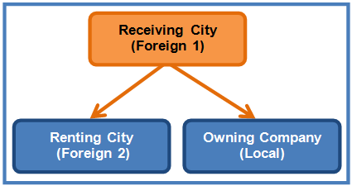
Scenario 3: Closing a Rent Back/ Send Back

Victoria Downtown rents a Budget Vancouver vehicle to Nanaimo Downtown. Interbranch Manager will create a contract in both Devon and Budget Vancouver’s GIS using Victoria’s contract number as the foreign contract number.

When the customer drops off the vehicle at Nanaimo Downtown, Devon’s CSR can retrieve the contract by the foreign contract number and check in the contract.

Interbranch Manager will replicate the closing information and any extra charge items on the contract to Budget Victoria and Budget Vancouver. This contract will appear on Budget Victoria’s Interbranch Transaction Module and Budget Victoria’s DOP can pull out the original contract, review to ensure the charges are correct, collect payment and check in the vehicle. This contract will also appear on Budget Vancouver’s Interbranch Transaction Module and Budget Vancouver’s DOP can retrieve the contract for closing.

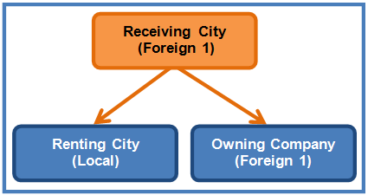
Scenario 4: Closing a Rent Back/ Send Back

Vancouver Downtown rents a Devon vehicle to Nanaimo Downtown. Interbranch Manager will create a contract in Devon’s GIS using Vancouver’s contract number as the foreign contract number.

When the customer returns the vehicle to Nanaimo Downtown, Devon’s CSR can retrieve the contract by the foreign contract number and check in the contract.

Interbranch Manager will replicate the closing information and any extra charge items on the contract to Budget Vancouver. This contract will appear on Budget Vancouver’s Interbranch Transaction Module and Budget Vancouver’s DOP can pull out the original contract, review to ensure the charges are correct, collect payment and check in the vehicle.

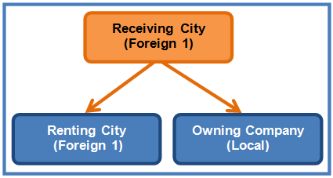
Scenario 5: Closing a Local Rental

Nanaimo Downtown rents a Budget Vancouver vehicle around town. Interbranch Manager will create a contract in Budget Vancouver’s GIS using Devon’s contract number as the foreign contract number.

When the customer drops off the vehicle at Nanaimo Downtown, Devon’s CSR can retrieve the contract by the foreign contract number and close it.

Interbranch Manager will replicate the closing information and any extra charge items on the contract to Budget Vancouver. This contract will appear on Budget Vancouver’s Interbranch Transaction Module and Budget Vancouver’s DOP can pull out the original contract, review to ensure the charges are correct, collect payment and check in the vehicle.

- Changes During Rental

The renting city must approve any changes in an interbranch contract and initiate those changes from GIS. Obtaining authorization is critical as it mainly allows the renting city to obtain additional authorization/funds on the customer’s credit card. Some vehicles might also be due for turnback and might be prohibited from rental extension, so it is always a good idea to double check with the renting city.

Contract Extension

If the changing city does not belong to the same owning company
- Must contact renting city for authorization (or obtain PO number)
- Once approved, renting city will extend the contract and obtain additional credit card authorization in GIS
- Data will be replicated to vehicle’s owning company and receiving city

Scenario:

If the changing city belongs to the same owning company or receiving city
- Must contact renting city for authorization
- Once approved, renting city will extend the contract and obtain additional credit card authorization in GIS

Change Drop Off Location

Changing city must contact the renting city for authorization.
(Even the changing city is part of the owning company)
- Renting city will provide drop charges to changing city
- Renting city will update the drop off location, trigger the new drop charge in GIS, and obtain additional credit card authorization in GIS
- Data will be replicated to vehicle’s owning company and receiving city
  - If the change in drop off location results in the removal of an owning company from the contract, then Interbranch Manager will void the auto-generated contract on the GIS of the owning company of the original receiving city.

Eg. Nanaimo Downtown rents a Victoria unit to Vancouver Downtown but the customer has a change of plans and wants to drop off the vehicle at Victoria Downtown.

Once Nanaimo Downtown updates the drop off location in Contract Changes, Interbranch Manager will notice that Budget Vancouver is no longer involved in the rental and will void the contract on Budget Vancouver’s GIS.

The auto-generated contract on Budget Victoria’s GIS will be updated with Victoria Downtown as the new drop off location.

  - If the change in drop off location results in the addition of a new owning company to the contract, then Interbranch Manager will automatically generate an opened contract in the GIS of the owning company of the new receiving city.

Eg. Nanaimo Downtown rents a Victoria unit locally but the customer decides to drop off the vehicle at Vancouver Downtown instead.
Once Nanaimo Downtown updates the drop off location in Contract Changes, Interbranch Manager will automatically create a new opened contract on Budget Vancouver’s GIS.

The auto-generated contract on Budget Victoria’s GIS will also be updated with Vancouver Downtown as the new drop off location.

Additional and/ or Removal of Coverage, Optional Extra

Changing City:
Must inspect vehicle and contact Renting City prior to add or remove any items for the Original rental agreement

Coverage - LDW / PAI / PEC / ELI
The charges on the above coverage are based on the rate sold from the "Renting City"
Authorization must be obtained from the Renting City due to different policy between Owning Company

- Change City - if approved, manually add on the Rental Agreement of the effective date and time of the item/s and have the customer sign to accept the changes
- A copy of the changes is to be fax to DOP department of the Renting City
Renting city will update the changes in GIS and obtain additional credit card authorization in GIS and/or process additional fund on credit card. Once updated, the information will replicate over to the owning city and the receiving city.

Optional Extra - Baby Seat/ GPS/ SKI Rack
The charges on the above Optional Extra are based on the rate sold from the "Changing City"
- Manually add on the Rental Agreement of the item and have the customer sign to accept the changes.
- A copy of the changes is to be fax to DOP department of the Renting City
Renting city will update the changes in GIS and obtain additional credit card authorization in GIS and/or process additional fund on credit card. Once updated, the information will replicate over to the owning city and the receiving city.

Optional Extra - Out of Area charges
Must call to obtain authorization from Renting City
(Even the "Change City" is part of Owning Company)
Renting city will update the changes in GIS and obtain additional credit card authorization in GIS and/or process additional fund on credit card. Once updated, the information will replicate over to the owning city and the receiving city.

Additional Driver
Must call to obtain approval from Renting City
(Even the "Change City" is part of Owning Company) - due to minimum age requirement among owning company)
Renting city will update the changes in GIS and obtain additional credit card authorization in GIS and/or process additional fund on credit card. Once updated, the information (charge item) will replicate over to the owning city and the receiving city.

Vehicle Problem

Possible scenario: Seattle rents a Victoria car to Victoria but the vehicle breaks down in Vancouver. Vancouver may or may not do the replacement, if Vancouver does do the replacement, then Vancouver has to open a contract from Vancouver to Victoria, which will be replicated to Victoria’s GIS, so Victoria would have 2 contracts in this case. If Vancouver doesn’t do the replacement, then it would be a foreign check in.

Possible scenario: Devon rents a Victoria car to Vancouver but the vehicle breaks down in Victoria. If Victoria replaces the unit, then the data gets replicated to Devon and Vancouver’s GIS. If Victoria closes the contract, data gets replicated to Devon and the contract in Vancouver’s GIS is voided.

If a vehicle on contract breaks down due to an accident or mechanical problem,
- Replacement provided - The changing city must contact the renting city for authorization and a purchase order before making any replacement
  - If the replacement is approved
- No replacement provided
  - Check in the vehicle with the actual date in, time in, KM in and the fuel charge. The Inter-branch manager will replicated over to the database of the renting city and the owning city of the vehicle.

Note that the customer is required to fill out an "Accident Report" if involved in an accident.

Replacement (Contract exist in GIS)
- If approval for replacement vehicle - ( Vehicle belongs to the same Owning Company)
- User can make the vehicle replacement in the GIS system - follow the procedure of Vehicle Replacement

- If approval for replacement vehicle - (Vehicle belong to another Owning Company – GIS member)
- User can make the vehicle replacement in the GIS system - follow the procedure of Vehicle Replacement

Replacement (Non-GIS members)
- If approval for replacement vehicle - User will open a new contract in GIS system for replacement. The original contract number will need to be entering in Comment and copy of the open contract will fax over to Renting City and Owning Company of the vehicle. Renting city will update the replacement in GIS.

Transaction initiated from Renting City

Renting City
(Foreign 1)
Renting City
(Foreign 1)

Receiving City
(Local)
Owning Company
(Local)
Receiving City
(Local)
Owning Company
(Foreign 2)

Renting City
(Foreign 1)
Renting City
(Foreign 1)

Receiving City
(Foreign 1)
Owning Company
(Local)
Receiving City
(Foreign 2)
Owning Company
(Local)

Renting City
(Foreign 1)
Receiving City
(Local)
Owning Company
(Foreign 1)

Transaction initiated from Receiving City

Receiving City
(Foreign 1)
Receiving City
(Foreign 1)

Renting City
(Local)
Owning Company
(Local)
Renting City (Local)
Owning Company
(Foreign 2)

Receiving City (Foreign 1)
Receiving City
(Foreign 1)

Renting City
(Foreign 2)
Owning Company
(Local)
Renting City (Local)
Owning Company
(Foreign 1)

Receiving City (Foreign 1)

Renting City
(Foreign 1)
Owning Company
(Local)

Transaction initiated from Owning Company

Owning Company
(Foreign 1)
Owning Company
(Foreign 1)

Renting City
(Local)
Receiving City
(Local)
Renting City
(Foreign 2)
Receiving City
(Local)
Owning Company
(Foreign 1)
Renting City
(Local)
Receiving City
(Foreign 1)
Owning Company
(Foreign 1)
Renting City
(Local)
Receiving City
(Foreign 2)
Owning Company
(Foreign 1)
Renting City
Foreign 1)
Receiving City
(Local)
- Contract Adjustment

Contract Adjustment

Sending
Receiving
Owning

Any adjustments along with internal comment will be updated among the Renting City, Owning City and Receiving City within the database of the GIS system. The revenue split will be calculated according from the adjustment and the user can decide whether or not to import the adjustment to ACCPAC.

What trigger an Interbranch contract between GIS systems?
Any one of the Renting city, Owning city and Receiving city are not belong to the same Company.

A module under Contract will be created showing all contracts requires to obtain additional authorization, check in contract and process payment and/or process additional payment.

Scenario 1) One Way
- Vancouver rent a BRAC vehicle one way to Nanaimo Airport with contract number 1434233
- This transaction meets the above criteria and an Inter-branch Manager created contracts between GIS systems. A rental agreement is created in Devon’s system by the inter-branch Manager as Contract #3032833 with Vancouver contract # 1434233 as foreign contract #
- When the customer dropped the vehicle at Nanaimo Airport on the due date, the user at Nanaimo Airport can retrieve the contract by
  - Foreign Contract #
  - Customer Last Name and First Name
  - Unit Number
  - Licence Plate Number
and update the rental agreement (3032833)
- Upon contract checked in, the Inter-branch manager will replicated over to Vancouver database between GIS system
- The DOP in Vancouver can pull out the original RA 1434233, review to ensure the charges are correct, collect Payment, check in the vehicle and update the rental agreement. A module under Contract will be created to show all contract need to be closed that was dropped at a foreign location

The Inter-branch Accounting will not have any entries unless the vehicle is not return full with fuel. If there is any fuel charge, the Vancouver Inter-branch Accounting will have a “Due to” entry to Devon for fuel and Devon Inter-branch Accounting will have a “Due From” entry from Vancouver for fuel.

Scenario 2) Rent/Sent Back
- Vancouver rent a Devon vehicle one way to Nanaimo Airport with contract number 1434218
- This transaction meets the above criteria and an Interbranch contract is created between GIS systems. A rental agreement is created in Devon’s system by the inter-branch manager as Contract #3032834 with Vancouver contract # 1434218 as foreign contract #
- When the customer dropped the vehicle at Nanaimo Airport on the due date, the user at Nanaimo Airport can retrieve the contract by
  - Foreign Contract #
  - Customer Last Name and First Name
  - Unit Number
  - Licence Plate Number
and update the rental agreement (3032834)
- Upon contract checked in, the Inter-branch manager will replicated over to Vancouver database between GIS system
- The DOP in Vancouver can pull out the original RA 1434218, review to ensure the charges are correct, collect Payment, check in the vehicle and update the rental agreement. A module under Contract will be created to show all contract need to be closed that was dropped at a foreign location

The Inter-branch Accounting will have entries between BRAC and Devon. Vancouver Inter-branch Accounting will have a “Due to” entry to Devon for revenue commission split based on One Way agreement and Devon Inter-branch Accounting will have a “Due From” entry to Vancouver for revenue.

Scenario 3) Rent/Sent Back
- Vancouver rent a Victoria vehicle one way to Nanaimo Airport with contract number 1434220
- This transaction meets the above criteria and an Interbranch contract is created between GIS systems. A rental agreement is created in Devon’s system by the inter-branch transaction manager as Contract #3032803 with Vancouver contract # 1434220 as foreign contract #. A rental agreement is created in Victoria’s system by the inter-branch manager as Contract #2935325 with contract # 1434220 as foreign contract #.
- When the customer dropped the vehicle at Nanaimo Airport on the due date, the user at Nanaimo Airport can retrieve the contract by
  - Foreign Contract #
  - Customer Last Name and First Name
  - Unit Number
  - Licence Plate Number
and update the rental agreement (3032803).
- Upon contract checked in, the information will be replicated over to Vancouver database and Victoria database.
- The DOP in Vancouver can pull out the original RA 1434220, review to ensure the charges are correct, collect Payment, check in the vehicle and update the rental agreement.

The Inter-branch Accounting will have entries between BRAC, Victoria and Devon. Vancouver Inter-branch Accounting will have a “Due to” entry to Victoria for revenue commission split based on One Way agreement, Victoria Inter-branch Accounting will have a “Due From” entry to Vancouver for revenue, and Devon Inter-branch Accounting will only have an entry of “Due From” from Victoria if the fuel is not full when vehicle return to Nanaimo Airport.

Scenario 4) Local Rental
- Vancouver rent a Devon vehicle locally in Vancouver contract number 1434295
- This transaction meets the above criteria and an Interbranch contract is created between GIS systems. A rental agreement is created in Devon’s system by the inter-branch transaction manager as Contract #3032900 with Vancouver contract # 1434295 as foreign contract #.
- When the customer dropped the vehicle at Nanaimo Airport on the due date, the user at Nanaimo Airport can retrieve the contract by
  - Foreign Contract #
  - Customer Last Name and First Name
  - Unit Number
  - Licence Plate Number
and update the rental agreement (3032900).
- Upon contract checked in, the information will be replicated over to Vancouver database.
- The DOP in Vancouver can pull out the original RA 1434295, review to ensure the charges are correct, collect Payment, check in the vehicle and update the rental agreement.

The Inter-branch Accounting will have entries between BRAC and Devon. Vancouver Inter-branch Accounting will have a “Due to” entry to Devon for revenue (no commission) based on One Way agreement, Devon Inter-branch Accounting will have a “Due From” entry to Vancouver for revenue (no commission).

Scenario 5) Replacement Vehicle
- Vancouver rent a BRAC vehicle locally to Vancouver with contract number 1434963
- When the customer drove pass Campbell River Airport, the vehicle has problem with the engine light and request to switch to another vehicle.
- Staff at Campbell River Airport contacts Vancouver DOP to obtain authorization for replacement.
- Vancouver DOP authorized the replacement in the modules of Contract Changes. Click the button of Authorized replacement; enter the replacement location and PO #. Once the changes are update in Vancouver, rental agreement is created in Devon’s system by the inter-branch manager as Contract #3033000 and with Vancovuer contract # 1434963 as foreign contract #.
- User at Campbell River can go ahead to replace the vehicle for the customer. The replacement vehicle information will replicated over to the database of the owing city of the vehicle and the renting city,

The Inter-branch Accounting will have an entry depending whether there is any fuel and/or whose vehicle was replace in this scenario. If replacement is with a BRAC vehicle, there will not be any Accounting entries. If there is any fuel charge, the Vancouver Inter-branch Accounting will have a “Due to” entry to Devon for fuel and Devon Inter-branch Accounting will have a “Due From” entry from Vancouver for fuel.
If replacement is with a Devon vehicle, the Inter-branch Accounting will have entries between BRAC and Devon. Vancouver Inter-branch Accounting will have a “Due to” entry to Devon for no. of day’s revenue and all optional sales of the replacement vehicle (no commission), and Devon Inter-branch Accounting will only have an entry of “Due From” from Vancouver for the no. of days revenue and all optional sales of the replacement vehicle (no commission).

If replacement is with a Victoria vehicle, the Inter-branch Accounting will have entries between BRAC, Victoria and Devon. Vancouver Inter-branch Accounting will have a “Due to” entry to Victoria for no. of day’s revenue and all optional sales of the replacement vehicle (no commission) as per One way agreement, Victoria Inter-branch Accounting will have a “Due From” entry to Vancouver for no. of day’s revenue and all optional sales of the replacement vehicle (no commission) as per One way agreement, and Devon Inter-branch Accounting will only have an entry of “Due From” from Vancouver if the fuel is not full when vehicle dropped to Campbell River for vehicle replacement.

How to handle in case Foreign DOP department is not available?

A manual contract will need to open for vehicle replacement and continue locating the foreign DOP department for approval and update to the system.
Once the update is done, one can update the replacement vehicle to the system.

- Appendix

Interbanch Entries for Contract Open/Check Out

Renting City Owning Company
The Business Transaction for Contract Open/Check Out will have:
- RBR Date = current RBR date
- Transaction Date = current date
- Transaction Type = “CON”
- Transaction Description = “Check Out”
- Contract Number = current Contract Number
- Confirmation Number = null
- Sales Contract Number = null
- Location ID = ID of location where Open/Check Out entered
- User ID = User ID of user who entered Open/Check Out
- Entered On Handheld = no
- Signature Required = no when a pre-write for a contract opened from a Maestro reservation which is Fastbreak, Executive Action or Applicant Status, yes otherwise.
- IBX Send = yes

For each contract checked out, an IBX Transaction will be written to the GIS database. Contracts with just an “Opened” status are ignored. This is done through a process that is scheduled to run every seven minutes.

The IBX Transaction for Contract Open/Check Out will have:
- Business Transaction ID = Business transaction number of the contract
- Trans Type = CO
- RBR Date = current RBR date
- Contract number = current Contract Number
- Vehicle Ownership = ID of owning company of vehicle on contract
- Renting Compay ID = ID of owning company of pick up location
- Receiving Company ID = ID of owning company of drop off location
- Transaction Description = Check Out
- Processed = no
- Last Updated On = current date

Vehicle Owning Company/Receiving City Owning Company
A Business Transaction will also be generated in the GIS database of the Vehicle Owning Company or/and Receiving City Owning Company during the replication from the Renting City Owning Company.

The Business Transaction for Contract Open/Check Out will have:
- RBR Date = current RBR date
- Transaction Date = current date
- Transaction Type = “CON”
- Transaction Description = “Check Out”
- Contract Number = current Contract Number
- Confirmation Number = null
- Sales Contract Number = null
- Location ID = ID of admin location of Vehicle Owning Company/Receiving City Owning Company
- User ID = Interbranch
- Entered On Handheld = no
- Signature Required = no
- IBX Send = no

Interbanch Entries for Contract Changes During Rental

Renting City Owning Company
The Business Transaction for Contract Open/Check Out will have:
- RBR Date = current RBR date
- Transaction Date = current date
- Transaction Type = “CON”
- Transaction Description = “Check Out”
- Contract Number = current Contract Number
- Confirmation Number = null
- Sales Contract Number = null
- Location ID = ID of location where Open/Check Out entered
- User ID = User ID of user who entered Open/Check Out
- Entered On Handheld = no
- Signature Required = no when a pre-write for a contract opened from a Maestro reservation which is Fastbreak, Executive Action or Applicant Status, yes otherwise.
- IBX Send = yes

For each contract checked out, an IBX Transaction will be written to the GIS database. Contracts with just an “Opened” status are ignored. This is done through the Gen IBX Trans process that is scheduled to run every seven minutes.

The IBX Transaction for Contract Open/Check Out will have:
- Business Transaction ID = Business transaction number of the contract
- Trans Type = CO
- RBR Date = current RBR date
- Contract number = current Contract Number
- Vehicle Ownership = ID of owning company of vehicle on contract
- Renting Compay ID = ID of owning company of pick up location
- Receiving Company ID = ID of owning company of drop off location
- Transaction Description = Check Out
- Processed = no
- Last Updated On = current date

Vehicle Owning Company/Receiving City Owning Company
A Business Transaction will also be generated in the GIS database of the Vehicle Owning Company or/and Receiving City Owning Company during the replication from the Renting City Owning Company.

The Business Transaction for Contract Open/Check Out will have:
- RBR Date = current RBR date
- Transaction Date = current date
- Transaction Type = “CON”
- Transaction Description = “Check Out”
- Contract Number = current Contract Number
- Confirmation Number = null
- Sales Contract Number = null
- Location ID = ID of admin location of Vehicle Owning Company/Receiving City Owning Company
- User ID = Interbranch
- Entered On Handheld = no
- Signature Required = no
- IBX Send = no

